Chapter 17, Problem 22.

Calculate the Fourier coefficients for the function in Fig. 17.60.

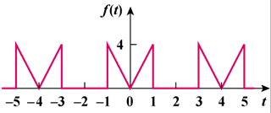

Figure 17.60
For Prob. 17.22.

